Name: B.Vinayani
Registration Number: 192472179

EXPERIMENT 12
Prompt Evaluation, Comparison and Refinement using LLM Responses

AIM
To design multiple prompts for a text-generation task, evaluate their outputs using predefined criteria (relevance, accuracy, completeness, clarity and format adherence) and refine the best-performing prompt.

PROCEDURE
1. Select the task: write a short note on the benefits of regular exercise for first-year college students.
2. Design three prompts of increasing detail: P1 (basic), P2 (adds role and audience) and P3 (adds word limit and exact structure).
3. Define the evaluation criteria and a 1-5 scoring scale: relevance, accuracy, completeness, clarity and format adherence (maximum 25).
4. Generate the output of each prompt and score it against the criteria (the program uses the LLM as a judge and also counts words and bullet points automatically).
5. Select the prompt with the highest total and note its weakest criteria.
6. Refine the best prompt to fix the weak criteria (P4), generate its output, score it again and compare it with the original.

PROMPTS AND CODE
Prompt P1 (basic):
Write about the benefits of exercise for students.

Prompt P2 (role and audience):
You are a college health counsellor. Write a short, friendly note for first-year college students explaining the benefits of regular exercise.

Prompt P3 (role, audience and format):
You are a college health counsellor writing for first-year students. Write a note of at most 100 words with: a one-line opening, exactly three bullet points (physical, mental and academic benefits) and a one-line closing call to action. Use simple, friendly language and avoid medical jargon.

Prompt P4 (refined version of P3):
You are a college health counsellor writing for first-year students. Write a note of at most 100 words with: a one-line opening, exactly three bullet points (physical, mental and academic benefits) and a one-line closing call to action. Use simple, friendly language and avoid medical jargon. Keep each bullet under 20 words, stay strictly within 100 words, and end with one practical tip, for example a 20-minute daily routine.

exp12_prompt_eval.py
"""Experiment 12 - Prompt evaluation, comparison and refinement.

Several prompts for the same text-generation task are run, scored against a
rubric (relevance, accuracy, completeness, clarity, format adherence) and the
best prompt is refined using the weaknesses found in its evaluation.
"""
import json
import os
import re
import sys

from openai import OpenAI

MODEL = "gpt-4o-mini"
CRITERIA = ["relevance", "accuracy", "completeness", "clarity", "format_adherence"]

PROMPTS = {
"P1": "Write about the benefits of exercise for students.",
"P2": ("You are a college health counsellor. Write a short, friendly note for first-year "
"college students explaining the benefits of regular exercise."),
"P3": ("You are a college health counsellor writing for first-year students. Write a note of "
"at most 100 words with: a one-line opening, exactly three bullet points (physical, "
"mental and academic benefits) and a one-line closing call to action. Use simple, "
"friendly language and avoid medical jargon."),
}

RUBRIC = """You are a strict evaluator. Score the TEXT from 1 (poor) to 5 (excellent) on each criterion:
- relevance: stays on the topic and suits first-year college students
- accuracy: every statement is factually correct
- completeness: covers physical, mental and academic benefits and ends with a call to action
- clarity: simple, friendly and easy to read
- format_adherence: at most 100 words, one-line opening, exactly three bullet points, one-line closing
Return only JSON with the keys relevance, accuracy, completeness, clarity, format_adherence."""

def chat(client, content, json_mode=False, temperature=0.7):
kwargs = {"response_format": {"type": "json_object"}} if json_mode else {}
reply = client.chat.completions.create(
model=MODEL, temperature=temperature,
messages=[{"role": "user", "content": content}], **kwargs)
return reply.choices[0].message.content.strip()

def auto_checks(text):
"""Objective format checks: word count and number of bullet points."""
words = len(text.split())
bullets = len(re.findall(r"^\s*[-*•]", text, re.MULTILINE))
return words, bullets

def evaluate(client, name, prompt):
text = chat(client, prompt)
scores = json.loads(chat(client, f"{RUBRIC}\n\nTEXT:\n{text}", json_mode=True, temperature=0))
words, bullets = auto_checks(text)
return {"name": name, "prompt": prompt, "text": text, "scores": scores,
"total": sum(scores[c] for c in CRITERIA), "words": words, "bullets": bullets}

def print_table(rows):
print(f"{'Prompt':<8}{'Words':>6}{'Bullets':>8}{'Rel':>5}{'Acc':>5}{'Cmp':>5}{'Clr':>5}{'Fmt':>5}{'Total':>9}")
for r in rows:
s = r["scores"]
print(f"{r['name']:<8}{r['words']:>6}{r['bullets']:>8}{s['relevance']:>5}{s['accuracy']:>5}"
f"{s['completeness']:>5}{s['clarity']:>5}{s['format_adherence']:>5}{str(r['total']) + '/25':>9}")

def refine(client, best):
weak = sorted(CRITERIA, key=lambda c: best["scores"][c])[:2]
request = (
"Improve the PROMPT below so that its output scores higher on these weak criteria: "
f"{', '.join(weak)}. The output currently has {best['words']} words and {best['bullets']} bullets. "
"Keep the task and the audience the same. Return only the improved prompt.\n\n"
f"PROMPT:\n{best['prompt']}")
return chat(client, request, temperature=0.3), weak

def main():
key = os.getenv("OPENAI_API_KEY")
if not key:
sys.exit("Error: set the OPENAI_API_KEY environment variable first.")
client = OpenAI(api_key=key)

print("=== Round 1: evaluating prompts ===")
rows = [evaluate(client, name, prompt) for name, prompt in PROMPTS.items()]
print_table(rows)
best = max(rows, key=lambda r: r["total"])
print(f"\nBest prompt: {best['name']} ({best['total']}/25)")

refined_prompt, weak = refine(client, best)
print(f"Weakest criteria: {', '.join(weak)}")
print("\n=== Refined prompt (P4) ===")
print(refined_prompt)

print("\n=== Round 2: evaluating refined prompt ===")
refined = evaluate(client, "P4", refined_prompt)
print_table([best, refined])
print(f"\nImprovement: {best['name']} {best['total']}/25 -> P4 {refined['total']}/25")

if __name__ == "__main__":
main()

OUTPUT
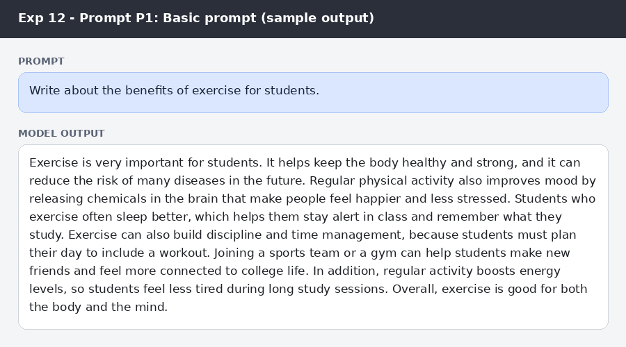
Figure: Prompt P1 (basic prompt) and sample output
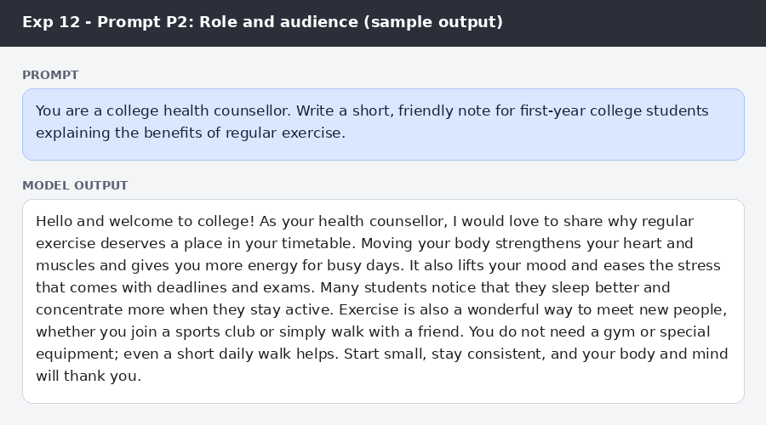
Figure: Prompt P2 (role and audience) and sample output
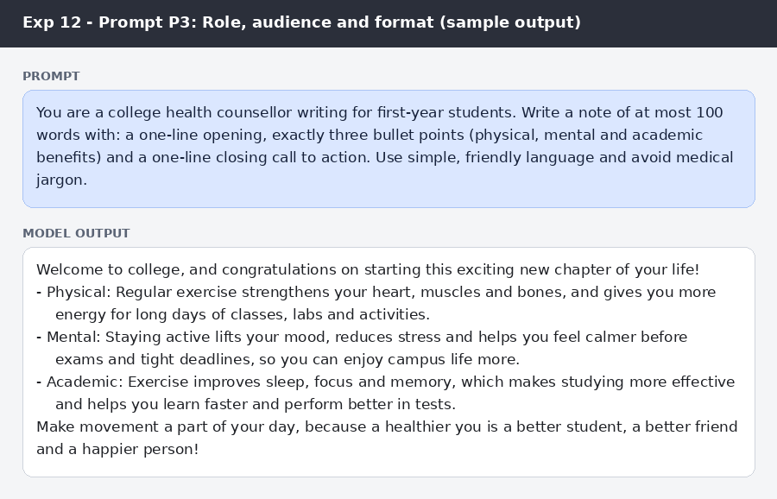
Figure: Prompt P3 (role, audience and format) and sample output
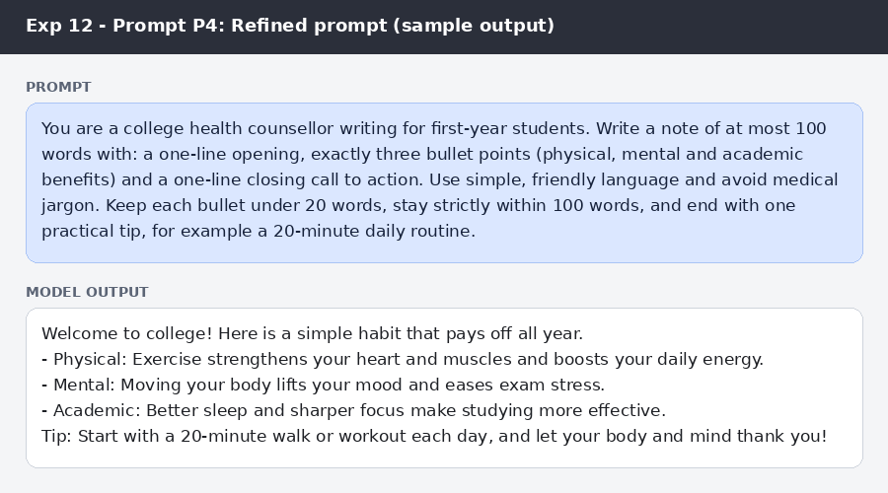
Figure: Prompt P4 (refined prompt) and sample output
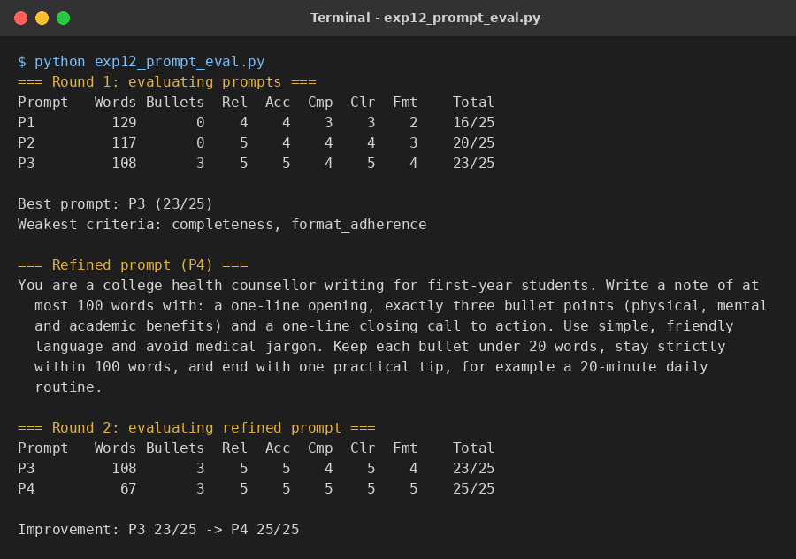
Figure (program) 1: Sample output of the program
Evaluation of the prompts (score 1-5 for each criterion)
Criteria | P1 Basic | P2 Role + audience | P3 Role + format | P4 Refined
Relevance | 4 | 5 | 5 | 5
Accuracy | 4 | 4 | 5 | 5
Completeness | 3 | 4 | 4 | 5
Clarity | 3 | 4 | 5 | 5
Format adherence | 2 | 3 | 4 | 5
Total (out of 25) | 16 | 20 | 23 | 25
Words / bullets | 129 / 0 | 117 / 0 | 108 / 3 | 67 / 3
Main observation | Generic, long, no structure | Friendly tone, but one paragraph and no fixed format | Right structure, but 108 words (over the limit) and no practical tip | Within limit, 3 bullets and a practical tip

RESULT
P1 scored 16/25, P2 scored 20/25 and P3 scored 23/25, so P3 was the best prompt. Its weaknesses were completeness (no practical tip) and format adherence (108 words against a limit of 100). The refined prompt P4 added a per-bullet length limit, a strict word limit and a practical-tip requirement; its output had 67 words, three bullets and a tip, and scored 25/25.

CONCLUSION
Prompt quality can be measured by scoring outputs against fixed criteria. Adding role, audience, structure and limits steadily improved the responses, and refining the best prompt using the weakest criteria gave a further improvement. Evaluating and refining prompts in this way is a systematic route to reliable LLM output.

